**Database Documentation**

**Database Description:** As per the project description, our database is for a system of three hospitals, each with three doctors, five nurses, and a maximum of ten patients. Hospitals also order medication from pharmacies. This is shown in our ER diagram and schema table, below.

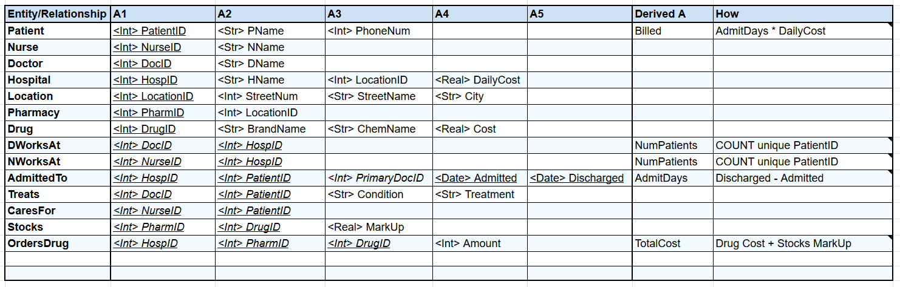

**Database Files and Folders:** The following outlines all the folders and files.

C3150/README.md: README file, contains all relevant information on how to use/run our database.

C3150/Documentation: All files related to documentation or descriptive information regarding the project.

C3150/Queries: All Query files including EMRSCHEMA, InsertQuery, SelectQuery, etc. (See README for instructions on how to run these). It also contains ComplexQueries which are derived attributes, and TestQueries which contain some queries for testing the constraints.

C3150/Queries/Inserts: The same as InsertQuery, but divided into separate files for each table.

C3150/TestData: csv files for using BulkInsert.

C3150/OneTouchEMR: Front-end UI made by Shieanne.

C3150/Extras: Helper files for the front-end UI made by Shieanne.

**Database Details:** As presented in our diagram, schema, and video, our solution fulfills all the requirements of the project by storing data in a 3NF normalized database. The constraints are all applied in the ConstraintsQuery and TriggerQuery files, which prevent illegal data from being inserted into the database. Most constraints and decisions regarding keys are intuitive, so we shall explain our decisions and limitations only for the more complex ones:

1. AdmittedTo has HospID, PatientID, Admitted, and Discharged as a primary key; this allows the same patient to be admitted to the hospital on numerous occasions. If the key was only HospID and PatientID, the patient would only be able to be admitted into each hospital once.

2. Treats has DocID and PatientID as a primary key; this was chosen to maintain simplicity—if a patient has multiple conditions, we thought it would be likely that a different doctor would be more proficient at treating each different issue. As you can see in our sample data, the Illness and Treatment are very general conditions (as we are not medical experts) so this simplicity functions well in our database. However, we do acknowledge that in a more complex database, a more detailed approach may be preferred. For instance, Illness might be a separate entity which is categorized by ConditionType (e.g. a variety of different heart conditions would be categorized as ‘Cardiological’). A similar approach may be necessary for Treatment, including some way to link Treatment with Drug. If we had more time, we would have loved to model this for you.

3. AdmittedTo has a TotalCost derived attribute which is calculated by multiplying the number of Days that a patient was admitted to the hospital by that hospital’s DailyCost; this was also chosen to maintain simplicity. We understand that different patients may need specialized testing or medication as a part of their stay/treatment at the hospital, which may contribute to a greater bill. However, much like the previous limitation, this complex relationship is not only outside of the scope of our project, but difficult for us as we do not have much knowledge about specific conditions, treatments, and costs related to hospital equipment/drugs. Likewise, if we had more time to research and implement this relationship, it would be a very interesting feature that we would love to add.

4. Drug has a Cost attribute, and Stocks has a MarkUp attribute; when a Hospital OrdersDrug from a Pharmacy, the cost is computed by multiplying the drug Amount * Cost * MarkUp, where MarkUp is a percentage. This allows Pharmacy to increase or decrease prices for certain drugs (e.g. if a drug is on sale), and a more interesting method of ordering drugs, where a Hospital can compare prices across pharmacies to choose the cheapest one.